

dashboarding

**ali raza’s ecommerce sales analysis**

**Project For Resume**



**Created by: Ghulam Hussain**

**https://github.com/ghulamhussainkhuhro/Ecommerce_Sales_Analysis**

January 14, 2025

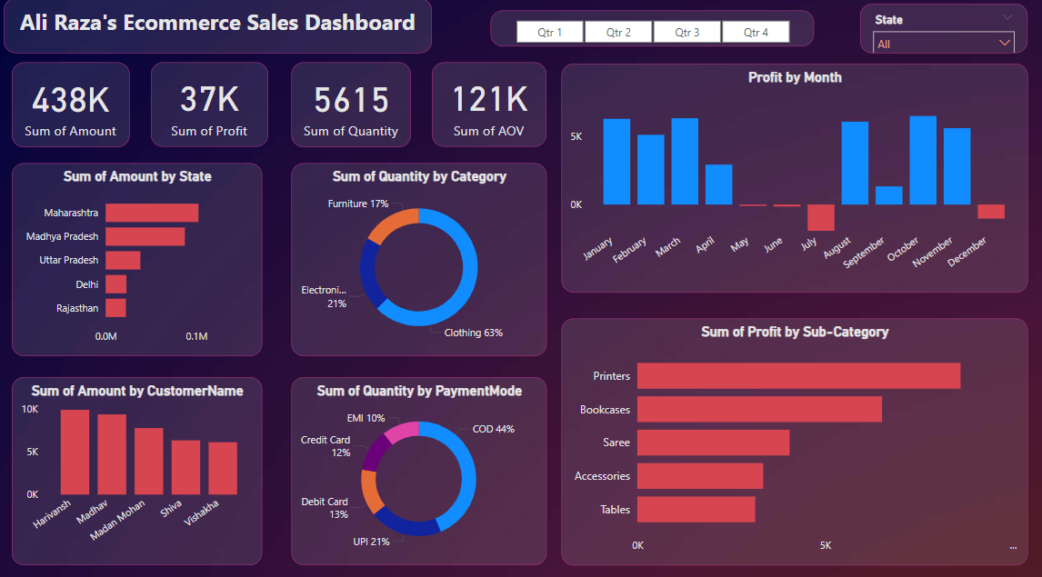

**Key Insights and Learnings: Storytelling the Dashboard Journey**

In today’s digital age, e-commerce platforms are treasure troves of data, brimming with valuable insights that can drive business success. This project, an **E-commerce Sales Dashboard**, was born out of a passion for transforming raw data into meaningful stories. It not only showcases sales performance but also empowers stakeholders to make data-driven decisions. Here's the journey and the insights uncovered:

**A Dive into the Numbers: Key Metrics at a Glance**

The dashboard paints a vivid picture of the e-commerce business's performance with these headline figures:

* **Total Sales Amount:** A remarkable **₹438K**, reflecting the scale and success of the platform.
* **Total Profit:** A healthy **₹37K**, showcasing effective business strategies.
* **Total Quantity Sold:** **5,615 units**, highlighting robust customer engagement.
* **Average Order Value (AOV):** ₹121K, emphasizing high-value transactions.

These top-level metrics immediately capture the magnitude of the platform's operations and set the stage for deeper analysis.

**Exploring Regional Performance: Where Sales Shine Brightest**

The dashboard reveals that **Maharashtra** is a powerhouse of sales, contributing the highest revenue. Following closely are **Madhya Pradesh** and **Uttar Pradesh**, with smaller but significant contributions from **Delhi** and **Rajasthan**. This regional insight helps prioritize market strategies and focus efforts on high-performing states.

**The Power of Categories: What Customers Love**

Analyzing product categories uncovers some fascinating trends:

* **Clothing:** Dominates with **63% of total quantity sold**, reflecting its universal appeal and high turnover.
* **Electronics:** Accounts for **21%**, signifying a growing demand for tech products.
* **Furniture:** A solid **17%**, indicating consistent interest in home essentials.

This data highlights customer preferences and guides inventory planning and promotional strategies.

**Payment Preferences: The COD Phenomenon**

The analysis of payment modes reveals that **Cash on Delivery (COD)** dominates, accounting for **44%** of transactions. Other modes include:

* **UPI Payments:** Growing steadily with **21%** of total sales.
* **Debit and Credit Cards:** Representing **13% and 12%**, respectively, showing a trend toward digital adoption.
* **EMI Payments:** A niche but notable **10%**, catering to high-ticket purchases.

Understanding payment preferences is vital for enhancing the customer experience and introducing targeted offers.

**Profit by Sub-Categories: What Drives the Bottom Line**

The dashboard delves deeper into profitability and highlights key contributors:

* **Printers:** Top the chart, delivering the highest profits.
* **Bookcases:** Another high-performing sub-category, valued for their utility.
* **Accessories, Sarees, and Tables:** Consistently contribute to profitability, showcasing the diversity of product offerings.

These insights help optimize inventory and promotional strategies to focus on high-margin products.

**Monthly Trends: The Peaks and Valleys of Profitability**

The **Profit by Month** visualization uncovers fascinating seasonal trends:

* Peaks in **August, September, and October**, likely driven by festive shopping sprees.
* A significant dip in **July**, hinting at a potential off-season.

These insights enable businesses to align marketing campaigns and stock levels with demand patterns.

**Customer-Specific Insights: Who Buys the Most**

The **Sum of Amount by Customer Name** chart reveals top buyers like **Harivansh**, **Madan Mohan**, **Shiva**, and **Vishakha**, who contribute significantly to sales. These insights pave the way for personalized marketing strategies, loyalty programs, and customer engagement initiatives.

**Learnings from the Journey: From Raw Data to Actionable Insights**

The creation of this dashboard was a transformative experience, with several key learnings:

1. **Storytelling with Data:** I discovered the power of visualizations in narrating a compelling business story.
2. **Complex Data Integration:** Merging datasets (Orders.csv and OrderDetails.csv) required precision and a clear understanding of relationships between tables.
3. **Dynamic Exploration:** By using filters, slicers, and interactive parameters, I made the dashboard adaptable to user-driven analysis.
4. **Visual Appeal:** Designing the dashboard with a gradient background added a professional, modern touch.
5. **Insights-Driven Thinking:** Identifying trends, patterns, and actionable insights helped me hone analytical skills.

This project was more than just data analysis; it was an opportunity to make data accessible, insightful, and actionable for stakeholders. The dashboard now stands as a testament to my skills in data visualization and storytelling, ready to drive real-world impact.